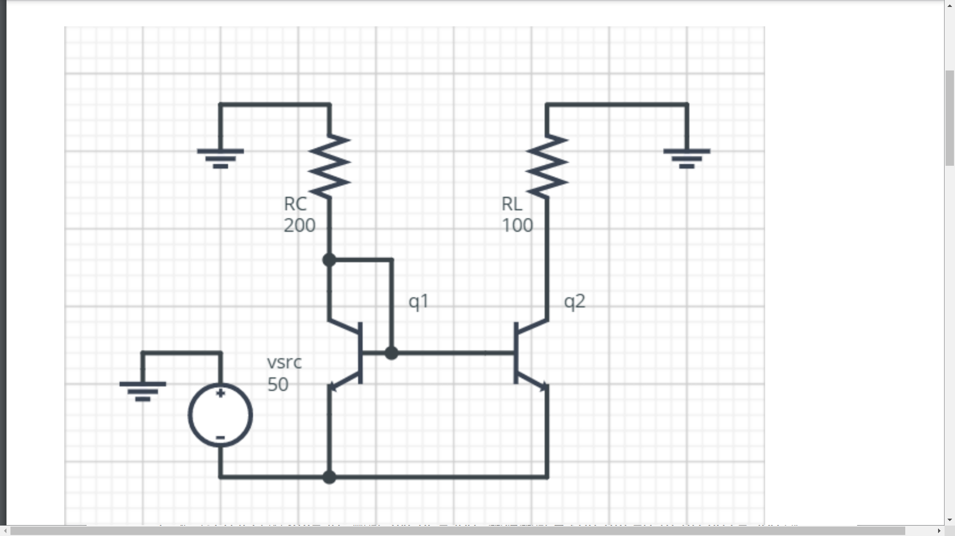

Ic

Vce = 50 – 49.3

Vce = 50 – 44.82

皆為Ib

I’

I

Hfe = 20

點X

V = -49.3

V = -50

Vbe = 0.7

RL = 200(圖上錯了)

耐壓 3W

For q1:

I = 49.3/Rc = 49.3/200 = 0.2465(A) = Ic + 2Ib

= 22/20 Ic

Ic = 0.224(A)

Ib = 0.0112(A)

For q2:

I’ = Ic

Vx = I’ \* 0.224 \* 200 = 44.82(V)

q1功率 = Ic\* Vce = 0.224 \* 0.7

q2 功率 = I’ \* Vce = 0.224 \* 5.18

理想current source的輸出阻抗為無限大

如果RL換的話，會影響q2的Vc、Vce、功率

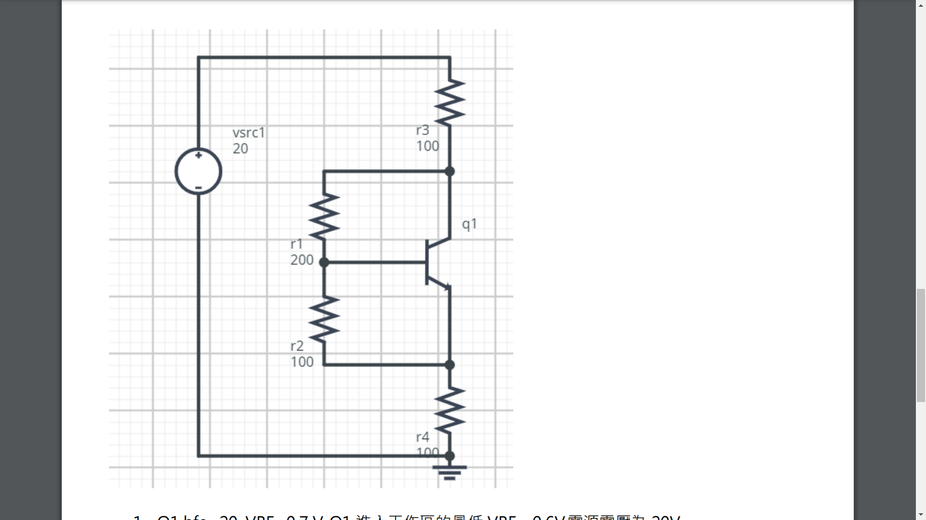

Ib

I2

I1

Ie

Ic

I

V(r2) = 100 \* 20/500 = 4

Q1 hfe=20, VBE=0.7 V, Q1 進入工作區的最低 VBE =0.6V

先假設電晶體不導通，就變成一個單純只有電阻的電路

I2 = 20/500

因為V(r2) = 4 > 0.6，所以電晶體導通，加入電晶體開始運算

=>Vbe = 0.7 => V(r2) = 0.7，I2 = 0.7/100

I = I1 + Ic = I1 + 21Ib

I1 = Ib + I2 = Ib + 0.7/100

Ic = 20Ib

Ie = 21Ib

用柯西赫夫電壓定理:

2I \* 100 + I1 \* R1 + 0.7 = 20

r3&r4改電阻，重複上述動作

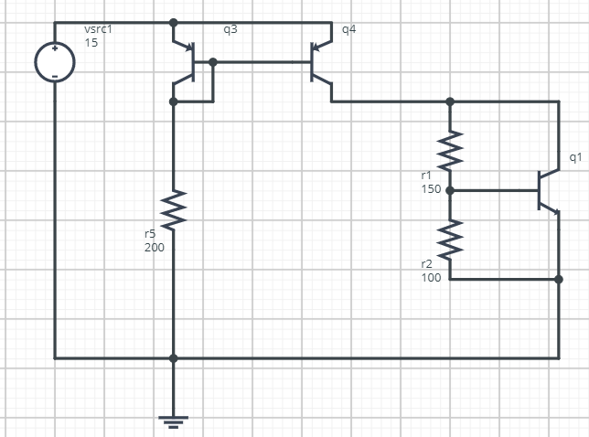

I